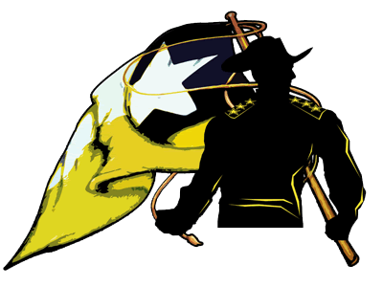
Art 1 Syllabus
Lee High School 2013-2014
6529 Beverly Hill Street • Houston, TX 77057-6406 • Phone: 713.787.1700 • Fax: 713.787.1723

Teacher: | Kevin Ellis
Contact Information: | kellis5@houstonisd.org
Educational Bio: | Graduate of Memphis College of Art (BFA)
Tutorial Hours: | Wednesday 4:15-4:45

Course Description:
Art 1 is an overview of the visual art world.
Students will gain an understanding of the elements and principles of art and will create a variety of art projects to get a feel for various materials and methods.
Class Goals:
- All students will pass this class with an 80% or higher.
- All students will attend class at least 95% of the time.
Objectives/Skills I Will Master By The End of the Semester: (3-5 bullets)
- How line, shape, color, space, texture, and value (the elements of art) are used to create a piece of artwork.
- To compare the use of line in art and mathematics.
- To create a color wheel that will demonstrate the artist’s comprehension of color application.
- To evaluate a work of art by dissecting it into the basic elements of art.

Class Expectations:
- Be on time
- Have all your supplies
- Participate in all activities
- Respect each other, the teacher, and all materials/equipment
- Clean your mess

Class Materials Needed: It is a REQUIREMENT to purchase these items.
- Color Pencils, Markers
- Sketchbook, Binder
- Mechanical Pencil or Pencil
- Images to use for inspiration and subject matter

___________________________________ ___________________________________
Student Signature/Date Parent Signature/Date

